| Course Name | ITD 2313 – Script Programming |
| --- | --- |
| Instructor | Mark Pranger |
| Student Name | Weston Albright |
| Due date | 05/06/2025 |
| Grade | N/A |
| Grading Comments | N/A |

Project 1

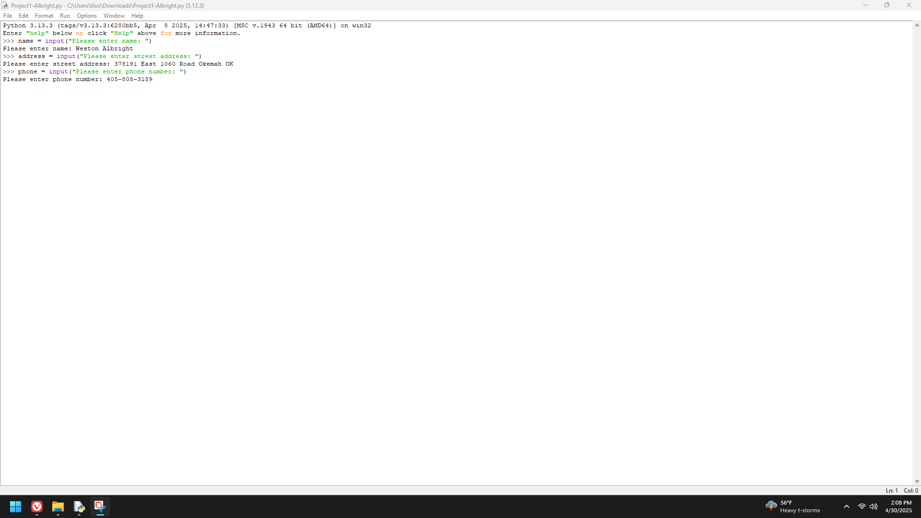

Project 2

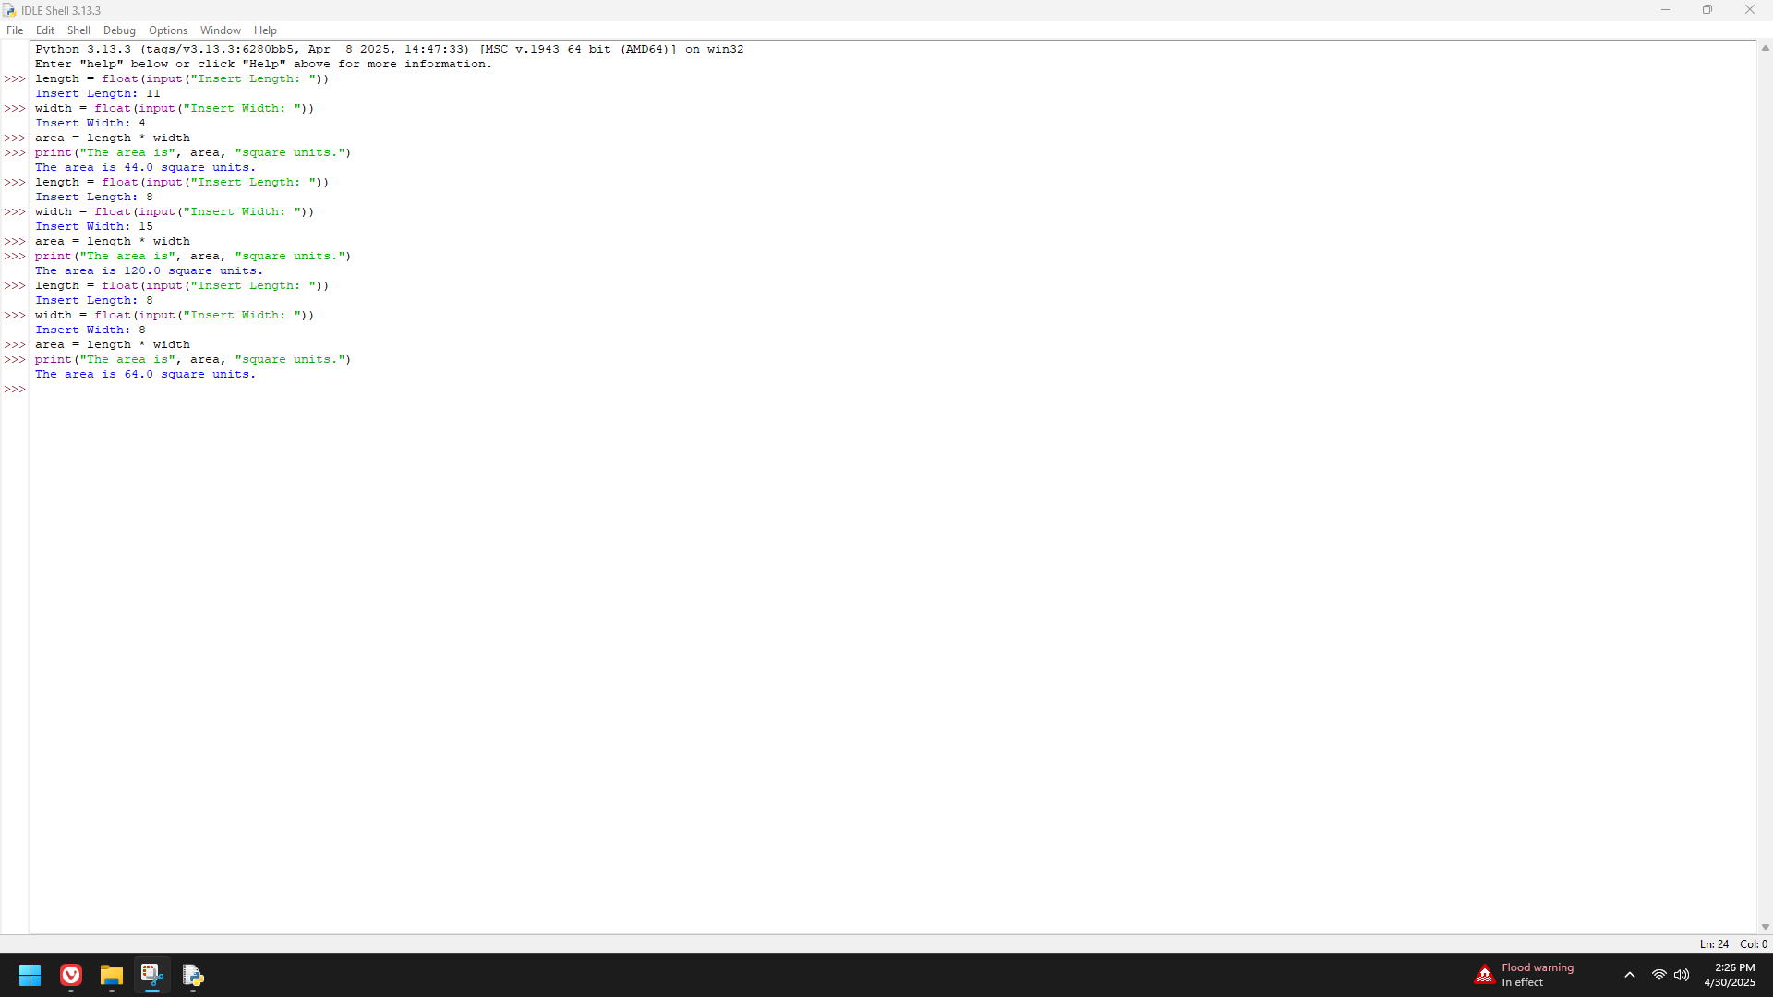

Project 3

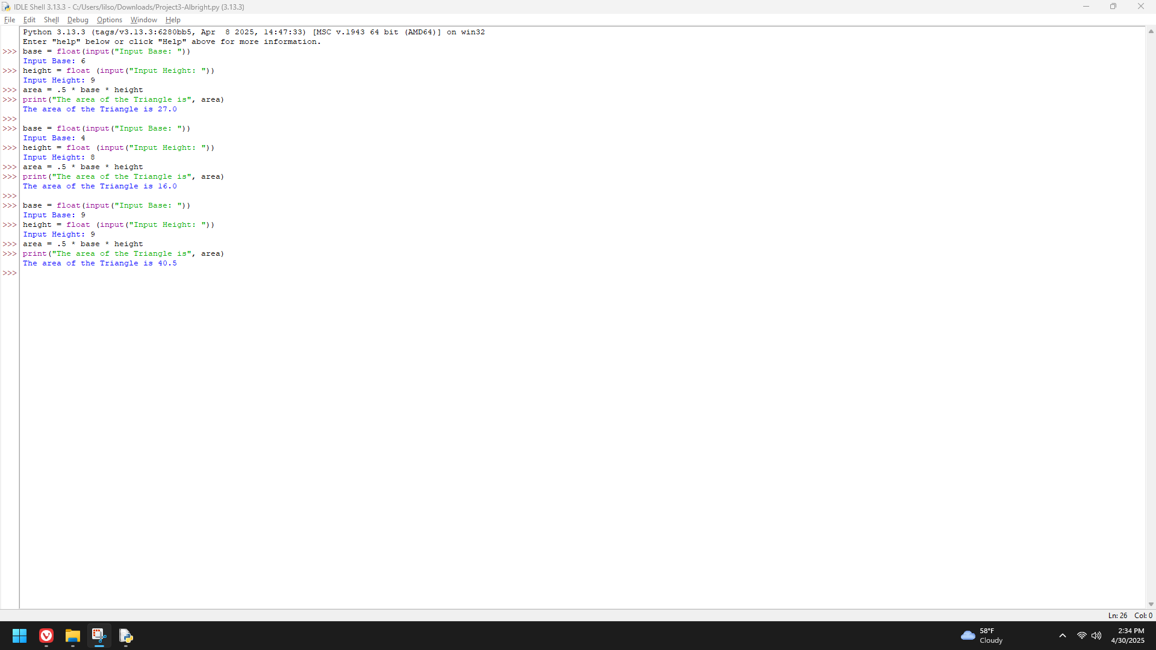

Project 4

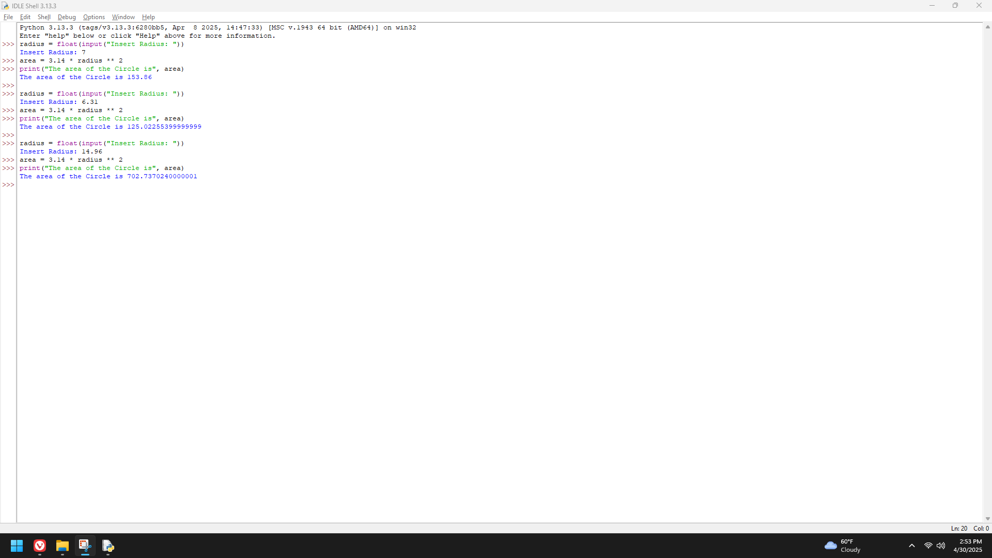

Project 5

